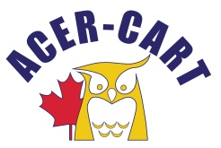
Association canadienne des enseignantes et des enseignants retraités
Canadian Association of Retired Teachers

Nov 1,2023

To: ACER-CART Executive

Re: Resignation

RTOERO has decided to withdraw from membership in ACER-CART effective December 31, 2023.

Since I hold my position on the ACER-CART Executive because of my membership in RTOERO, I can no longer continue in the position of ACER-CART President. The Executive will need to discuss measures it must take in this new reality and I should not be part of that discussion. Therefore, please consider this letter to be my resignation as President effective immediately.

As this change takes place in the middle of our year, I may well receive correspondence in the next few months and I will immediately pass anything received to Bill in his new role.

It has been an honour to have held this position and I have very much enjoyed working with all of you. I wish you and ACER-CART nothing but the best in the years ahead.

Sincerely,
Martin Higgs

