October 19, 2023

Martin Higgs
President
ACER-CART

Dear Martin,

Re: RTOERO membership in ACER-CART

I am writing to inform you, after considerable discussion and due consideration, that the Board of Directors of RTOERO approved a motion at its meeting on October 4, 2023 to withdraw our membership and associated funding in ACER-CART effective January 1, 2024.

Throughout the many years that RTOERO has been an active member of ACER-CART, our RTOERO representatives have enjoyed interacting with the many representatives of the other provincial and territorial associations.

I wish ACER-CART the very best wishes in its future initiatives.

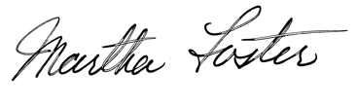
Sincerely

Martha Foster
Chair of the Board of Directors

