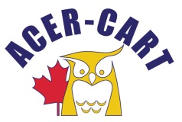
Association canadienne des enseignantes et des enseignants retraités
Canadian Association of Retired Teachers

March 22, 2023

Dear Members,

As the ACER-CART Executive begins its draft revisions to our Strategic Plan, we would appreciate input from all our Member organizations on some fundamental questions. Given our resources, we must focus our efforts to achieve the best results.
Please discuss these questions with your executives and return your answers to me by the end of April. We can then prepare for a fulsome discussion paper to be tabled and discussed at our Annual Meeting in Ottawa.
Thanks in advance for doing this and we look forward to working together to make ACER-CART as productive as possible.
All the best,
Martin Higgs
President

Key Questions:
- What should ACER-CART’s purpose be?
- What role(s) do you think it should and can fulfill?
- How can ACER-CART best support its Members?
- How can you, as a Member, support ACER-CART?
- Other relevant comments or suggestions.

Return as soon as possible. Deadline April 30, 2023,
Martin Higgs gmhiggs@outlook.com
Roger Régimbal regimbal.roger@sympatico.ca

