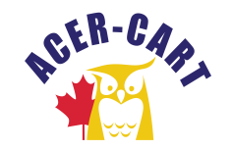

Canadian Association of Retired Teachers

Association canadienne des enseignantes et des enseignants retraités

EXECUTIVE MEETING
August 16, 2023, Special Executive
11 P.M. Ottawa Time
Agenda

- Call to order
- Approval of the agenda
- Conflicts of interest
- Strategic Plan
- Tentative dates for Executive meetings
  - September 2022, 2021 11:00 AM EDT
  - November 1, 2023, Board Meeting 11 AM EST.
  - January 2023 11:00 AM EST
  - March 2023, 11:00 AM EST
  - June 5, 2023, 9:30 EDT
- Adjournment

