Association canadienne des enseignantes et des enseignants retraités
Canadian Association of Retired Teachers

Date : August 12, 2023
From : Roger Régimbal Executive Director
To ; Executive
Objet : Special Executive meeting

Good morning,
I hope your summer is going fine, not too disturbed by water, wind and fires.
As you recall, we have scheduled a meeting of the executive for Wednesday, August 16th at 11 AM, Ottawa time. We agreed that this would be a one item agenda. Strategic Plan.

Martin and I met to develop th agenda, and the process to follow.
- August meeting to review the literature and begin the discussion.
- Martin will draft and share a first copy of the plan.
- We ask that you respond to this draft by the middle of September.
- Martin will update.
- We will review at our September meeting.
- The updated draft will be shared with directors prior to the November 1st meeting.
- A final version will be discussed at our January meeting.
- It will be presented at the AGM for Board’s approval.

I have reviewed the pertinent documents for your review prior to the meeting included them in this email. If you wish to add more, please share them.
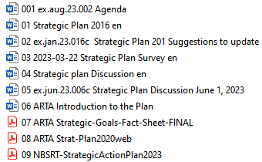
Thank you,
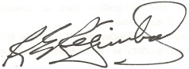
Roger Régimbal
Executive director

