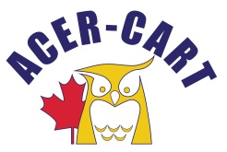
Association canadienne des enseignantes et des enseignants retraités
Canadian Association of Retired Teachers

Date : June 19, 2023
From : Roger Régimbal Executive Director
To : ACER-CART Executive
Objet : AGM Expenses

AGM 2023 EXPENSES
Executive expenses |  | 8 142,15 $
Hotel expenses |  | 22 881,15 $
Secretarial |  | 790,96 $
Printing |  | 540,54 $
Swags/ Books |  | 1 241,76 $
Set up/take down |  | 129,00 $
Suite |  | 1 987,68 $
Total |  | 35 713,24 $

Thank you
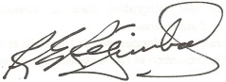
Roger Régimbal
Executive director

