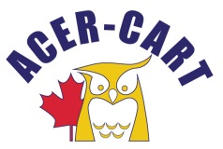
Association canadienne des enseignantes et des enseignants retraités
Canadian Association of Retired Teachers

PRESIDENT’S REPORT
April 11, 2023

President’s Report
Fairly quiet time
Sent out questionnaire re: Strategic Plan
Contacted Minister for Seniors re: speaking at our banquet
Contacted Richard Harrison from Johnson Inc. re: presentation at AGM & financial contribution
Arranged for ACER-CART representation at STS 50th Anniversary

Martin Higgs
President

