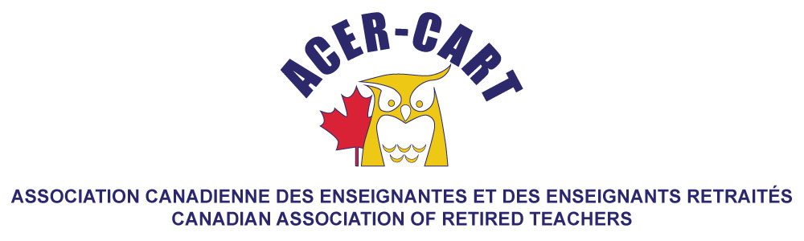
Ontario Report
August 2022

Martha Foster
Ontario Representative

Since our last meeting, the RTOERO board has had one Board meeting.

- The Board received the 2022 mid-year report on the progress in the focus areas for the Strategic Plan 2020-2025. This included the following areas: advocacy, DEI, partnerships, thought leadership, enhanced program services, environmental stewardship, member engagement in the change journey, support for volunteer recognition, broaden the membership base and building the brand.
- The Board approved the establishment of a partnership between RTOERO and the Canadian Deprescribing Network, effective September 2022.
- The Board reviewed Agendae for the District Presidents’ Workshop, the Board Planning Session and the Fall Forum.
- The Chair and CEO were invited to attend a meeting hosted by the International Longevity Centre regarding a proposal to join the Canadian Coalition Against Ageism. The decision of the Board was that RTOERO will participate in the further development of the Canadian Coalition Against Ageism and will host the next meeting in Toronto.
- The chair and vice chair had an excellent meeting with Federal Minister of Appropriations, Filomena Tassi.
- The benefits Committee reported on the RFP for the second opinion service fro insurance holders.
- Since we have last met, RTOERO has had 2 webinars, Strengthening your financial capability throughout the retirement journey and Une participation efficace des aînés dans les politiques publiques : de la consultation au partenariat.

