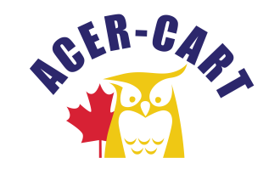**Association canadienne des enseignantes et des enseignants retraités**



**Canadian Association of Retired Teachers**

**NOMINATIONS AND ELECTIONS COMMITTEE REPORT**

**Report**

At the request of the Nominations & Elections Chair, the official Call for Nominations will be sent out on March 18, 2022 to the Members requesting that they submit nominations for officer positions on the ACER-CART Executive.

It was noted in the announcement that a nomination was to be presented by submitting the official form April 30th 2021.

By the announced date, the following positions are open for elections.

* President:
* Vice President
* Regional Representative - East:
* Regional Representative – Ontario:
* Regional Representative – West:
* Past-President - To be determined

Submitted by,

Bill Berryman, Chair

Nominations & Elections Committee