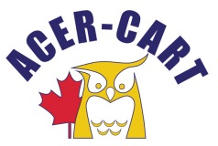
Association canadienne des enseignantes et des enseignants retraités
Canadian Association of Retired Teachers

PRESIDENT’S REPORT
March 17 , 2022

- Letters
  - Kamal Khera, Minister of Seniors
  - Jean-Yves Duclos, Minister of Health
  - Kamal Khera, Minister of Seniors, invitation to speak at our conference

- Committee meeting participation:
  - Communication committee – Missed it!
  - Political Advocacy Committee – January 19, February 15
  - East Coast ACER-CART – March 10

- Activities:
  - Monitor Saskatchewan’s use of New Mode. 1189 total submissions!

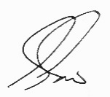
Gerry Tiede, President

