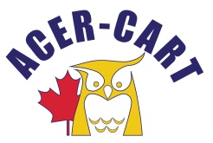
Association canadienne des enseignantes et des enseignants retraités
Canadian Association of Retired Teachers

Date : March 17, 2022,
From : Roger Régimbal Executive Director
Objet : Correspondance

Documents sent and received

Thank you
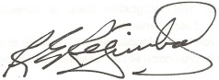
Roger Régimbal
Executive director

