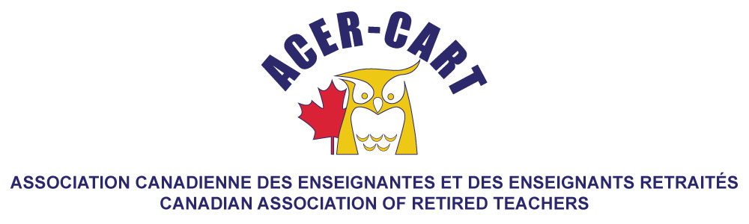
Ontario Report
January 2022

Martha Foster
Ontario Representative

Since our last meeting, the RTOERO board has not only had its regular Board meetings, but held a Special Meeting and their Biannual Forum.

The Special Meeting was to deal with a residual issue from the Annual Meeting and was finished in good time, from whis we then moved directly into the Forum. The Forum is generally an informational as well as a training session. In normal times, this is a two day event, but this event was held virually over 3 hours, which restricts the training that can be done. At the October Forum, we had presentations fron the two summer medical research students which RTOERO finances through a grant to the National Institure on Aging. Their areas of research were Out of Sight Out of Mind: Addressing the Invisible and Older Faces of Canada’s Opiod Crisis and Understanding the Experience of Geriatric Care Professionals Using Telemedicine to Care for Older Patients in Response to the COVID-19 Pandemic. RTOERO has provided this grant for a total of five years.

In October, we had our held our annual Queen’s Park Vibrant Voices campaign. We focus with the majority of sessions on one day, but over a period of two weeks we meet with MPPs and their staff to share with them out advocacy areas for the year. This event has grown each year and the virtual venu of the last two years has actually increased the number of MPPs with whom we engage. This year, not only are we continuing our sessions with the Ontario MPPs, but are planning a campaign with the MPs in Ottawa.

As a part of our advocacy campaign, we also carried out a number of webinars over the fall: Building an Eldercare System that Actually Works (André Picard); Saving the Forests Saving Us (Dr Diana Bresford-Kroeger) and The Indigenous Experience in Canada (Candy Palmater). At the same time, thte RTOERO Foundation held a series of three webinars. Both of these series are continuing this winter/spring with the start off Jan 25 with David Suzuki on Creating a Lasting Legacy through Environmental Stewardship.

We are continuing with our monthly Zoom meetings with our District Presidents. This started with the onset of the pandemic, to keep our local executives updated and on their request, is still continuing. We have added Vice Presidents and Unit Presidents to the meetings.

Although our elections are not until May, we are holding a session for individuals who are contemplating running for the Board, to give them an idea of what the job entails.We are holding a similar session for individuals interested in applying for committees or committee chairs or running for the Governance and Nomination committee (an elected position).

Since the pandemic, we have been running our Retirement Planning Workshops virtually and are continuing to do so this spring. Hopefully we will be able to hold them in person in the fall.

