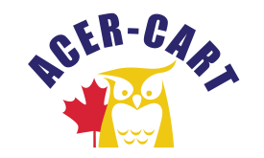
Association canadienne des enseignantes et des enseignants retraités
Canadian Association of Retired Teachers

Date : January 14, 2022
From : Roger Régimbal Executive Director
Objet : Activity Report

Since the meeting activities have been at a standstill. I dealt with issues that stemmed from that meeting and emerging issues. I also monitored like-minded organizations and forwarded the information where it was deemed necessary.

- Representation
Everything is on hold.

- Correspondence
I have received and respond to numerous emails since the June AGM. All letters written by the President have been dealt with. I have had no response.

- Financial Members might start to question the need of such an accumulation.
  - Report
The January 14, 2022, report shows minimal expenditures. We have a substantial amount in the bank and invested.
  - Membership
All membership dues have been paid. Please refer to Membership document

- Corporation Canada
According to the non-for-profit corporations Act, we must file an Annual Return Report due in January. I am awaiting their notice to file the report.

- AGM 2022
I have started to review the document needed to advise Members of the AGM. We will have to decide what venue we will have this year before I send the notifications

- Disposition of the AGM
The document has been updated.

- Presentation of Executive documents
At the last executive meeting there was a request from members that I present the documents as part of one document. I have been in touch with Muriel from RTOERO.
Unfortunately, I reached out too late for this meeting. She advises me that I need the program Adobe Acrobat Pro DC.

The cost is 264.00 $ annually. Seeing this, I thought it was in everyone’s interest to have the approval of the executive to authorize this expense.

- Conference call dates.
Date for the next executive meeting is March 17, 2022.

Thank you
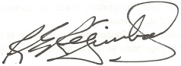
Roger Régimbal
Executive director

