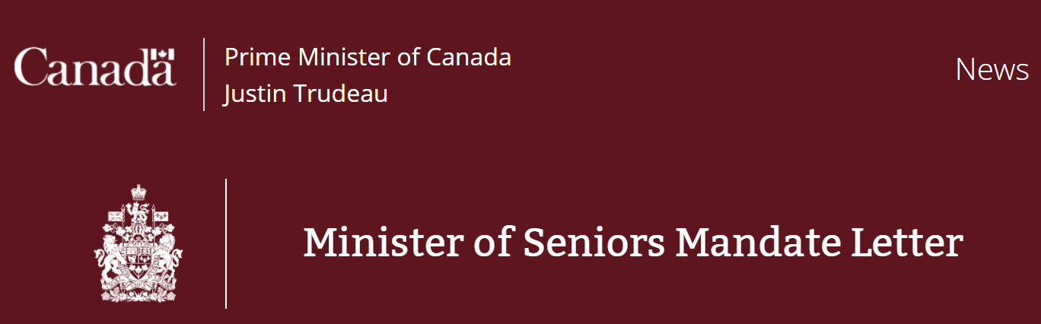

December 16, 2021
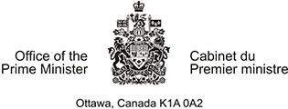
Dear Minister Khera:
Thank you for agreeing to serve Canadians as Minister of Seniors.
From the beginning of this pandemic, Canadians have faced a once-in-a-century challenge. And through it all, from coast to coast to coast, people have met the moment. When it mattered most, Canadians adapted, helped one another, and stayed true to our values of compassion, courage and determination. That is what has defined our path through this pandemic so far. And that is what will pave our way forward.
During a difficult time, Canadians made a democratic choice. They entrusted us to finish the fight against COVID-19 and support the recovery of a strong middle class. At the same time, they also gave us clear direction: to take bold, concrete action to build a healthier, more resilient future. That is what Canadians have asked us to do and it is exactly what our Government is ready to deliver. We will work to build that brighter future through continued collaboration, engagement, and the use of science and evidence-based decision-making. With an unwavering focus on delivering results, we will work constructively with Parliamentarians and maintain our strong partnerships with provincial, territorial and municipal governments and Indigenous partners. This decade has had an incredibly difficult start, but this is the moment to rebuild a more resilient, inclusive and stronger country for everyone.
The science is clear. Canadians have been clear. We must not only continue taking real climate action, we must also move faster and go further. As Canadians are increasingly experiencing across the country, climate change is an existential threat. Building a cleaner, greener future will require a sustained and collaborative effort from all of us. As Minister, I expect you to seek opportunities within your portfolio to support our whole-of-government effort to reduce emissions, create clean jobs and address the climate-related challenges communities are already facing.
This year, Canadians were horrified by the discovery of unmarked graves and burial sites near former residential schools. These discoveries underscore that we must move faster on the path of reconciliation with First Nations, Inuit and Métis Peoples. We know that reconciliation cannot come without truth and our Government will continue to invest in that truth. As Ministers, each of us has a duty to further this work, both collectively and as individuals. Consequently, I am directing every Minister to implement the United Nations Declaration on the Rights of Indigenous Peoples and to work in partnership with Indigenous Peoples to advance their rights.
We must continue to address the profound systemic inequities and disparities that remain present in the core fabric of our society, including our core institutions. To this effect, it is essential that Canadians in every region of the country see themselves reflected in our Government’s priorities and our work. As Minister, I expect you to include and collaborate with various communities, and actively seek out and incorporate in your work, the diverse views of Canadians. This includes women, Indigenous Peoples, Black and racialized Canadians, newcomers, faith-based communities, persons with disabilities, LGBTQ2 Canadians, and, in both official languages.
Across our work, we remain committed to ensuring that public policies are informed and developed through an intersectional lens, including applying frameworks such as Gender-based Analysis Plus (GBA Plus) and the quality of life indicators in decision-making.
Canadians continue to rely on journalists and journalism for accurate and timely news. I expect you to maintain professional and respectful relationships with journalists to ensure that Canadians are well informed and have the information they need to keep themselves and their families safe.
Throughout the course of the pandemic, Canadians and their governments have adapted to new realities. Governments must draw on lessons learned from the pandemic to further adapt and develop more agile and effective ways to serve Canadians. To this end, I expect all Ministers to evaluate ways we can update our practices to ensure our Government continues to meet the challenges of today and tomorrow.
The success of this Parliament will require Parliamentarians, both in the House of Commons and the Senate, to work together across all parties to get big things done for Canadians. I expect you to maintain constructive relationships with your Opposition Critics and coordinate any legislation with the Leader of the Government in the House of Commons. As Minister, you are accountable to Parliament both individually, for your style of leadership and the performance of your responsibilities, and collectively, in support of our Ministry and decisions taken by Cabinet. Open and Accountable Government sets out these core principles and the standards of conduct expected of you and your office. I expect you to familiarize yourself with this document, which outlines my expectations for each member of the Ministry.
Our platform lays out an ambitious agenda. While finishing the fight against the pandemic must remain our central focus, we must continue building a strong middle class and work toward a better future where everyone has a real and fair chance at success and no one is left behind.
As Minister of Seniors, your immediate priority is to support and help advance the Government’s commitment to increase Old Age Security and the Guaranteed Income Supplement. I also expect you to support the Minister of Health in improving the quality and availability of long-term care and to take concrete actions to support seniors who want to age at home. As well, you will continue to create opportunities for seniors to be more connected, supported, and active members of their communities through implementing the New Horizons for Seniors Program.
To realize these objectives, I ask that you achieve results for Canadians by delivering the following commitments.
- Building on our commitment to old age security, increase the Guaranteed Income Supplement by $500 for single seniors and $750 for couples starting at age 65.
- Ensure seniors’ eligibility for the Guaranteed Income Supplement is not negatively impacted by receipt of the Canada Emergency Response Benefit (CERB) and the Canada Recovery Benefit (CRB).
- Establish an expert panel to provide recommendations for establishing an Aging at Home Benefit. You will be supported by the Minister of Health in this work.
- Assist community-based organizations in providing practical support that helps low-income and otherwise vulnerable seniors age in place, and support regional and national projects that help expand services that have already demonstrated results in helping seniors stay in their homes.
- Work with the Minister of Families, Children and Social Development to provide seniors with a single point of access to a wide range of government services and benefits.
- Continue to work with the Minister of Justice and Attorney General of Canada to strengthen Canada’s approach to elder abuse by finalizing the national definition of elder abuse, investing in better data collection and establishing new offences and penalties in the Criminal Code related to elder abuse.
- Represent the Government of Canada at the Federal, Provincial and Territorial Ministers Responsible for Seniors Forum.
- Continue leading work within Employment and Social Development Canada on seniors’ programming including the New Horizons for Seniors Program.
- Support the Minister of Health in their work to improve the quality and availability of long-term care homes and beds. This includes working with provinces and territories to improve infection prevention and control measures, identify shared principles, and develop national standards to ensure seniors get the care they deserve.
As Minister, you are also responsible for actively engaging with your Cabinet and Caucus colleagues. As we deliver on our platform commitments, it will be important that members of the Ministry continue to collaborate and work constructively to support rigorous and productive Cabinet decision-making. I expect you to support your colleagues in delivering their commitments, leveraging the expertise of your department and your own lived experiences.
To best achieve results for Canadians, Ministers must be rigorous and coordinated in our approach to implementation. I would therefore ask that you return to me with a proposed approach for the delivery of your mandate commitments, including priorities for early implementation. Furthermore, to ensure we are accountable for our work, I will be asking you to publicly report to me, and all Canadians, on your progress toward these commitments on a regular basis.
As we have been reminded throughout the pandemic, adapting to change is not only something government should do, it is something government must do. As you work to fulfil our commitments, I expect you to actively consider new ideas and issues as they emerge, whether through public engagement, your work with Parliamentarians or advice from the public service. I also expect you to work with your Deputy Minister to assess priorities on a continual basis as we build a better future for all Canadians. In addition to achieving results, you are responsible for overseeing the work of your department and ensuring the effective operation of your portfolio.
As you staff your office and implement outreach and recruitment strategies for federally appointed leadership positions and boards, I ask that you uphold the principles of equity, diversity and inclusion. This helps ensure that federal workplaces are dynamic and reflective of the Canadians we serve. You will also ensure your Minister’s office and portfolio are reflective of our commitment to healthy and safe workplaces.
Canadians expect us to work hard, speak truthfully and be committed to advancing their interests and aspirations. When we make mistakes – as we all will – Canadians expect us to acknowledge them, and most importantly, to learn from them.
I know I can count on you to fulfill the important responsibilities entrusted in you, and to turn to me, and the Deputy Prime Minister, early and often to support you in your role as Minister.
Sincerely,
Rt. Hon. Justin Trudeau, P.C., M.P.
Prime Minister of Canada

