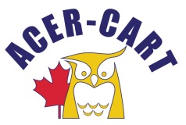
Association canadienne des enseignantes et des enseignants retraités
Canadian Association of Retired Teachers

PRESIDENT’S REPORT
January 14 , 2022

- Letters
  - Christmas message
  - Seniors’ Minister Khera

- Committee meeting participation:
  - Communications committee – Oct. 18. ’21: Jan. 7, ‘22
  - Pension and Retirement Income Committee – Dec. 3, ‘21
  - Health Services and Insurance Committee – Dec. 8, ‘21
  - Political Advocacy Committee – Nov. 2, ‘21

- Activities:
  - Communications with RTAM re using New Mode during February 2022. Gerry will coordinate with Paul Harland.

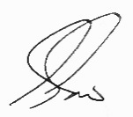
Gerry Tiede, 1President

