Association canadienne des enseignantes et des enseignants retraités
Canadian Association of Retired Teachers

Date: September 30, 2021
To: ACER-CART Executive
From: Marilyn Bossert
Re: Communications Committee Update

The 2021-22 Communications committee has not met, but that will happen soon. In the meantime, the Communication process continues…
Those indicating interest in serving on the committee are current members Linda LeBlanc (New Brunswick), Steve Bailey (British Columbia) and new member Joseph Lafitte (Newfoundland). Always included in our meetings will be Tony Esteves, Gerry Tiede, and Roger Régimbal.
Communications Mandate/Terms of Reference:
- Maintain the ACER-CART website.
- Produce information for use on the website and by Members.
- Encourage and facilitate communication among Members.
Website:
- Additions to the website:
- Advance Care Planning: An Essential Conversation for Everyone plus poster (April 7)
- The Need for a Seniors’ Strategy – Gerry’s letter to PM (April 15)
- Medication Safety & Deprescribing – submitted by Health Services (April 15)
- Health Survey - submitted by Health Services (April 18)
- General Vaccination Information for Seniors – submitted by Health Services (April 15)
- Health Services Survey Results - submitted by Health Services (April 18)
- Message from ACER-CART President (May 11)
- HSO Survey Collecting LTC information (May 18)
- Retiree Health Event (May 18)
- Seniors Issues for the 2021 Federal Election brochure (June 2)
- ACER-CART Banners ( June 2)
- Time for a National Seniors Strategy (August 22)
- Message from ACER-CART President (August 24)
- Election 2021 (August 25)
- National Seniors Strategy (August 30)

- Location changes on the home page to increase visibility
- Addition of a one-pager of questions to be asked of political candidates
Cross Canada Photos Submissions 30th Anniversary Project
- Opening for submissions coming soon

Analytics from the ACER-CART Website:
June 2021
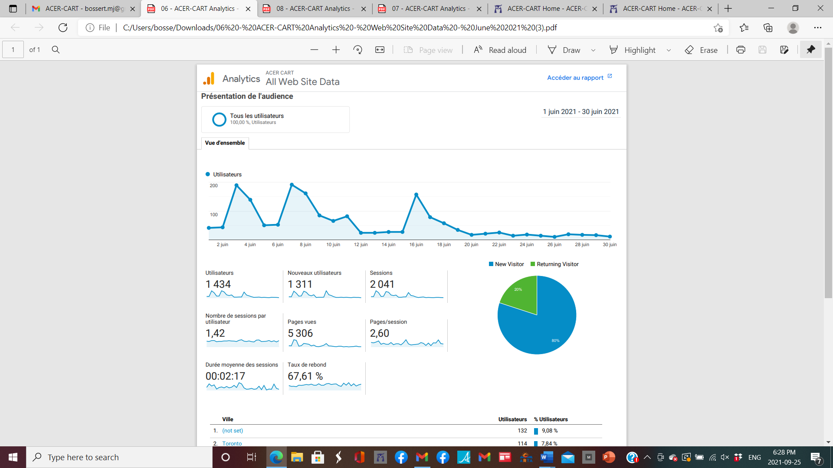
July 2021
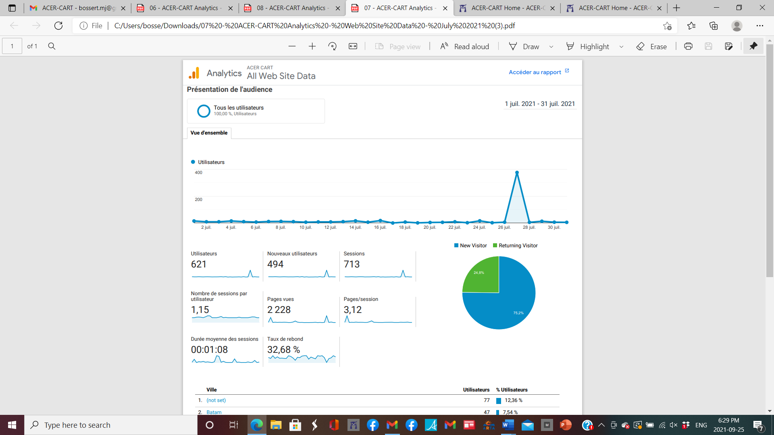

August 2021:
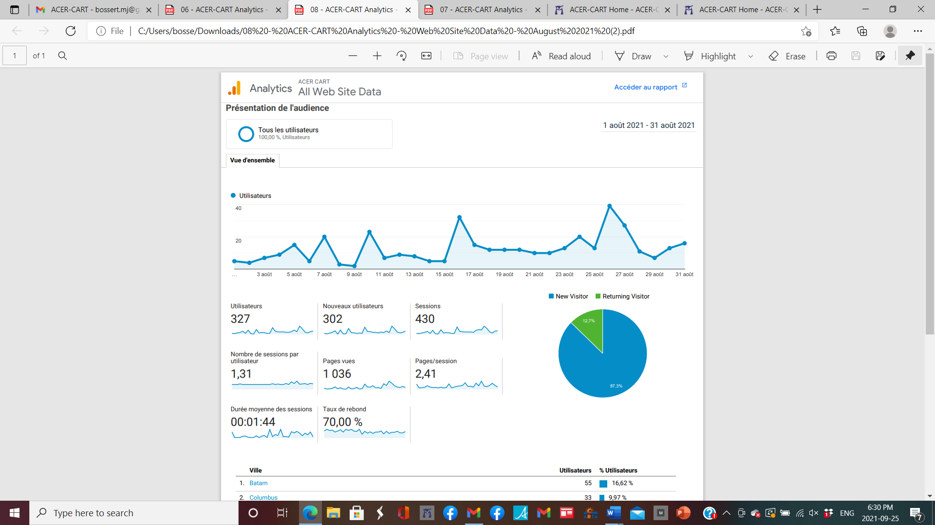

Cities of Origin:
 | June | July | August
1 | Not set 132 | Not set 77 | Bantam 77
2 | Toronto 114 | Bantam 47 | Columbo 22
3 | Calgary 103 | Columbus 22 | Shanghai 20
4 | Edmonton 95 | Shanghai 20 | Not set 13
5 | Regina 36 | Dhaka 13 | Toronto 11
6 | Parksville 32 | Calgary 12 | Tianjin 11
7 | Halifax 32 | Lagos 10 | Zhengzhou 11
8 | Saskatoon 29 | Edmonton 9 | Calgary 10
9 | Surrey 27 | Beijing 9 | Edmonton 10
10 | Vancouver 23 | Tianjin 9 | Beijing 7

- City of origin section is showing a high number of out-of-county visits.

Analytics from New Mode:

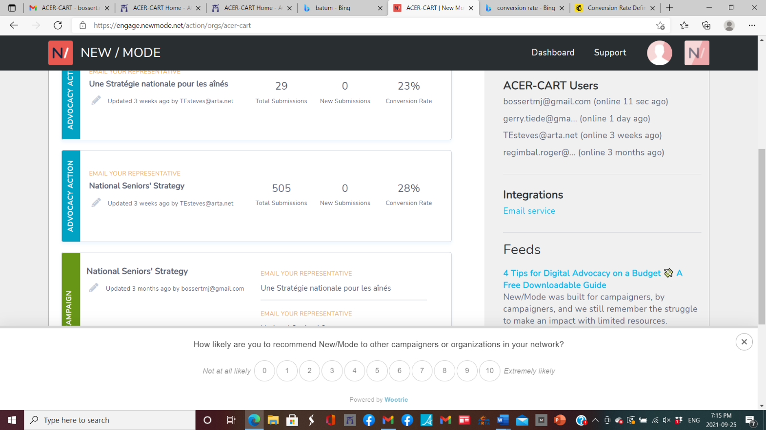
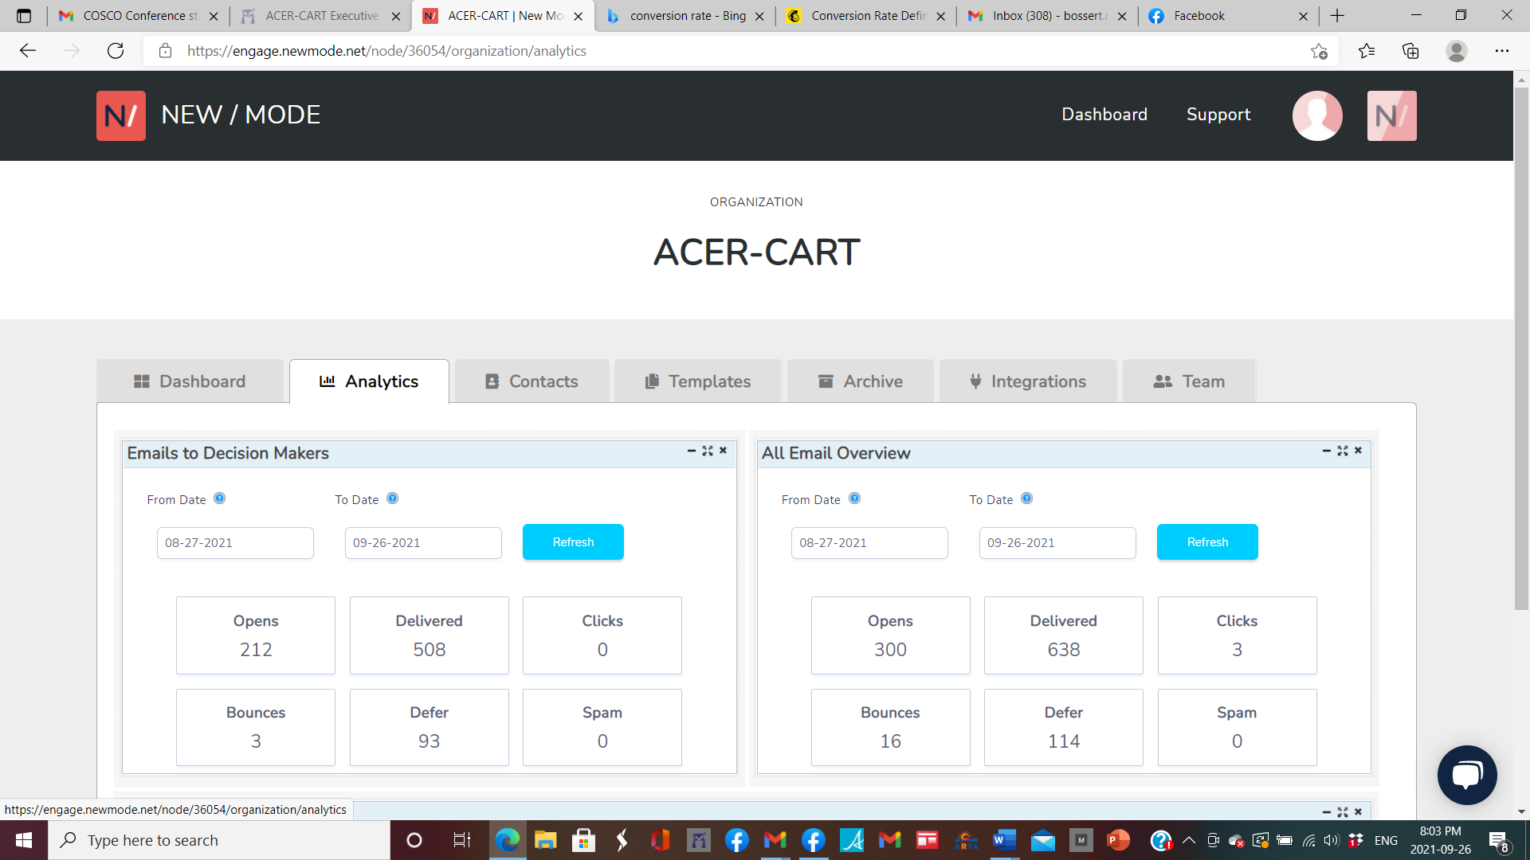

Respectfully submitted,
Marilyn Bossert

