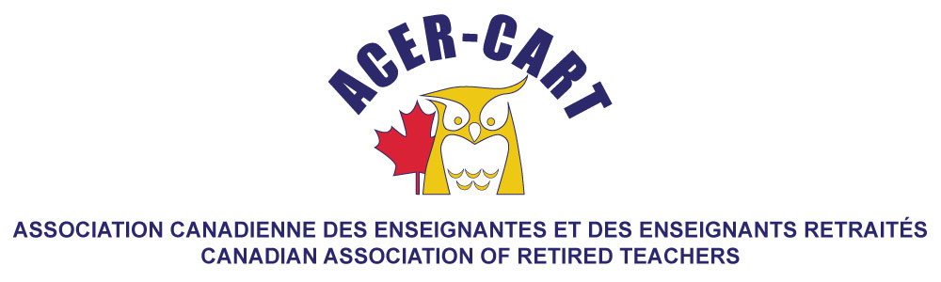
Ontario Report
October 2020

Since we last met, RTOERO has had its Annual Meeting and for the next 18 months, has a new Chair, Rich Prophet. Also, at the Annual Meeting, we established our strategic plan for the next 5 years and elected 3 members to the board. As with most of us, we held a virtual annual meeting and a virtual Forum, which we hold twice a year. Both meetings had their challenges, in that was not the same free floating discussion as usual, but we made it through both with minimal issues. We expect that our annual meeting in October will also be virtual.

In November we held our orientation and training session. The focus on training this year was board self-evaluatioin, as we are heading into that process. We have reviewed the mandates of our standing and advisory committees and letters have been sent to the chairs of those committees outlining their committees’ foci for this year.

Martha Foster
Ontario Representative

