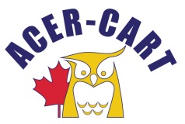
Association canadienne des enseignantes et des enseignants retraités
Canadian Association of Retired Teachers

PRESIDENT’S REPORT
Jan.14 , 2021

- Letters
  - Christmas letter to ACER-CART colleagues
  - Letter to Prime Minister re: Increasing the OAS for Canadians at 75 years of age.

- Presentation to RTAM Executive – Nov. 19

- Committee meeting participation:
  - Eastern Zone Directors – Nov. 13
  - Political Action Committee – Dec. 3, 2020, Jan. 7, 2021
  - Communication Committee – Dec. 9, 2021

- Issues from last meeting:
    - The President and the Executive Director will bring a proposal to our next Executive meeting that reduces the size of the AGM minutes but still references the appropriate reports. – We will reference but not include other documents, perhaps as Appendices.
    - The President will work with Committee Chairs to review and possibly update the standing committee terms of reference. The Legislative Committee has been working with committee chairs. A draft may be available?
    - The President will work with others to update our “Vision for Canada” document to reflect our current priorities and strategic plan by the end of this year. The contents are dependent on the approved actions being developed by the Political Action Committee. That work is well under way.

- Other issues for consideration:
  - Possibility of a federal election this Spring
  - Addressing provision of vaccines for seniors.
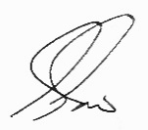
Gerry Tiede, President

