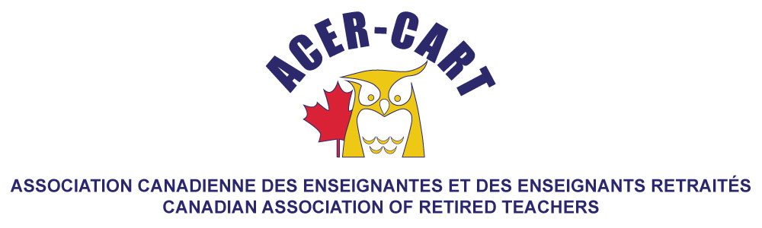
Ontario Report
October 2020

It has bee an extremely busy summer, early fall. The challenges of COVID-19 have created interesting challenges, as it has fo all of us.

Our office continues to function from the homes of our staff, with calls being routed to the homes of our receptionists. If you were to call the office, you would not know that the it was not fully staffed. On Oct 20, we will be holding our virtual Annual Meeting, with the new chair and vice chair chosen by the Board on Oct 21.

As a part of our response to the pandemic, we have also moved all our Retirement Planning Workshops to on line, with a huge up-tick of attendees. They can now attend any RPW and are not restricted to local sessions.

Another part of our pandemic response, is monthly meetings with all our District Presidents, weekly, then bi-weekly meeting of the Board and many of the Board members meeting monthly with their liaison regions. The increaased communication has been so well received, that we plan to keep it once we return to the old normal.

Advocacy remains a focal point of our activity. On October 1, International Day of the Older Persons and National Day of Seniors, we had the opportunity to have virtual meetings with a number of our Members of Parliament. It was and exciting day, with five teams consisting of Board Members, Members of our PAC committee and staff members sharing our advocacy issues: Geriatric Health Care, Environmental Sustainability and a Seniors’ Strategy, as well as our support of Bill 196, for a Senior’s Advocate. As a part of our advocacy, we are assisting our members in Saskatchewan and British Columbia who are heading towards elections, to address our issues and concerns with members of their legislature.

Exciting news for us, is that our membership continues to climb, the number of individuals who are apart of our insurance plan is just bodies away from 100 000.

Martha Foster
Ontario Representative

