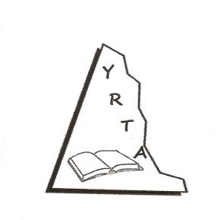

YUKON RETIRED TEACHERS’ ALUMNI

MEMBER ASSOCIATION REPORT
AGM 2019

- Major concerns of your Association:
As an association, YRTA has not been actively involved at the federal or territorial level in lobbying with concerns of particular interest to retired teachers. On the other hand, many Yukon retired teachers are very involved politically or with such organizations as the Yukon Council on Aging and in these roles the voices of our members are being heard. Concerns around senior housing, health care, senior tax benefits and abuse of the elderly are just some of the issues currently receiving attention.

Our members are appreciative of the efforts of ACER–CART in bringing issues of concern to retired teachers to the attention of the federal government. Recently the Petition for Pension Security was circulated to YRTA members and several responded.

- Main activities of your Association since last ACER-CART AGM:
Social activities continue to be the main focus of YRTA. Monthly breakfast gatherings are well attended, as are the Christmas and fall luncheons. Again our annual scholarships to two Yukon students in training to be teachers were presented. Another area of activity is in the area of volunteerism. Each year we receive contacts from a variety of organizations seeking retired teachers to help out with an event or project. We are particularly proud of the YRTA members who entered a beautifully decorated Christmas tree in the Yukon Hospital Foundation’s fundraiser, the Festival of Trees.

- AGM Motions from your Association to the ACER-CART AGM.
No motions will be presented by the YRTA.

Conclusion
Again this year, YRTA will not be represented at the 2019 ACER-CART AGM. Further, I will be leaving the position of the president of the Yukon Retired Teachers’ Alumni effective June 30, 2019.

Ken Nash
President YRTA

