Exclusive: Canada budget to include limited coverage for prescription drugs - sources
David Ljunggren, Anna Mehler Paperny

OTTAWA/TORONTO (Reuters) - Canada’s Liberal government will propose a limited expansion to the country’s universal healthcare system in the spring budget to cover part of the cost of prescription drugs, two sources with direct knowledge of the matter told Reuters.

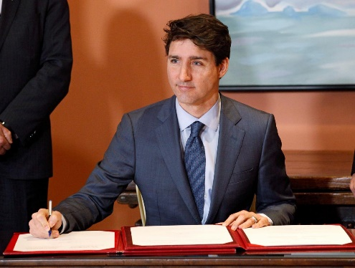

FILE PHOTO: Canadian Prime Minister Justin Trudeau signs a book as he shuffles his cabinet after the resignation of Treasury Board President Scott Brison, in Ottawa, Ontario, Canada, January 14, 2019. REUTERS/Patrick Doyle

The modest broadening of the healthcare program is set to become one of Prime Minister Justin Trudeau’s key campaign promises ahead of the October election, which is shaping up to be a close fight.

The government would not commit to meeting 100 percent of the cost of prescription drugs for those who have no insurance through their workplace, the sources said. That suggests the government is leaning toward a narrower, more insurance industry-friendly model of pharmacare, as it is called, than that recommended by a government health committee last year.

A spokesman for Finance Minister Bill Morneau declined to comment. Officials have yet to decide how much detail to provide about the pharmacare system in the budget, which is expected in the week of March 18, the sources said. They may release a general commitment to boost coverage and leave the specifics for the campaign, they added.

But new information on pharmacare’s inclusion in the spring budget and its limited scope gives a first glimpse of the government’s blueprint for what has been called the “unfinished business” of Canada’s publicly funded healthcare system, called medicare.

The sources, who spoke in recent days, requested anonymity because they were not authorized to speak to the media.

Canada’s health system covers care provided in hospitals and doctors’ offices, but prescription medication remains largely the purview of private insurance, often offered through employers, and a patchwork of public plans geared primarily toward the old and the very poor.

Opinion polls consistently show strong popularity for Canada’s public healthcare system. There have been calls for Canada to extend medicare to include prescription drugs since medicare came into existence in the late 1960s, and multiple studies have recommended its inclusion. Surveys have found 20 percent of Canadians are either uninsured for prescription drugs or under-insured, and one in 10 Canadians goes without prescription medications because of an inability to afford them, according to the standing committee on health’s pharmacare report released in April 2018. Manulife Financial Corp, Sun Life Financial Inc and Great West LifeCo are among the major insurers in Canada.

FILLING IN GAPS
The Liberal-dominated government health committee strongly recommended Canada adopt a universal, national pharmacare program that covers drug expenditures for all Canadians for a wide range of drugs.

That would not only improve equity and access, advocates said, but lower drug costs because there would only be one buyer negotiating with pharmaceutical companies.
The government’s budget watchdog estimated that would cost about C$20.4 billion ($15.5 billion) a year - a hefty price tag for the government but offering an overall saving of C$4.2 billion compared with the total now spent on prescription drugs.

What the government is likely to include in its budget is a much more targeted plan aimed at filling the gaps in coverage not already filled by private insurance or existing public plans, the sources said.
That matches with the government’s finance committee recommendation late last year, which Morneau, himself a former benefits industry executive, has said he would prefer.

It is also in line with what the insurance industry has been asking for. Standing to lose business to a universal government plan, the insurers have argued that most Canadians have good private coverage and that pharmacare changes need only affect a small uninsured minority.

But the Liberals will likely face criticism from policy advocates and left-leaning political opponents for not pursuing a more comprehensive plan. Without a universal system overhaul, advocates argue, people will continue to slip through costly cracks in the coverage system.

An advisory council appointed to study the implementation of pharmacare is expected to come out with recommendations this spring.
Reporting by David Ljunggren in Ottawa and Anna Mehler Paperny in Toronto; Editing by Denny Thomas and Peter Cooney

