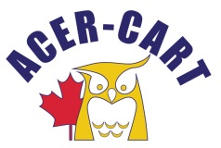
Association canadienne des enseignantes et des enseignants retraités
Canadian Association of Retired Teachers

November 21, 2018

Cynthia MacDonald,
President PEIRTA
105-9 Harley St.,
Charlottetown, PE C1A 5T7

Dear Cynthia:

I apologize for the tardiness in sending this letter, but as you will recall I left for a two-week Mediterranean cruise the day following our ECRTO Conference and returned safe and sound on November 11, 2018.

On behalf of the ACER-CART I extend a sincere thank you to you and your exceptional PEIRTA organizing committee for an excellent conference. I was very impressed by the expertise of Dr. Stephen Wong and Dale Weldon on their presentations on October 24th. The presentation by Olive Bryanton the following day was exceptional and I only hope I have the same amount of energy she provided when I reach her age!

The dinner provided by Rendez-vous Catering was superb and participants had an opportunity to walk off some of the calories consumed. Although not all participants attended the hospitality following the dinner, I can understand as some travelled a distance on the same day.

The table discussion on October 25th was very interesting and I look forward to Marg’s tabulations of the many points discussed. This information will help all six organizations in advancing the interests of our members and seniors in their respective provinces.

As all organizations had an opportunity to provide input in a collegial forum I close with the following quote, “If you want to go fast, go it alone. If you want to go far, go together.”

Thank you Cynthia for bringing us together with well-known Prince Edward Island hospitality and I look forward to seeing you at the AGM in June 2019.

Yours sincerely,
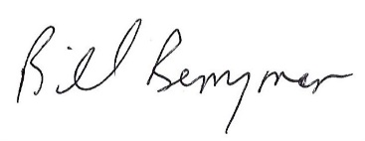
Bill Berryman
President

