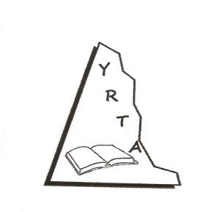

YUKON RETIRED TEACHERS’ ALUMNI

MEMBER ASSOCIATION REPORT

- Major concerns of our organization:
- Federal level:
Like seniors across Canada our members are concerned with the directions the federal government is taking with Health Care.

- Provincial level:
The main concern of YRTA members is seniors’ housing. A major project is underway which will provide much needed extended care facilities to seniors in the territory.

- Main activities of our Organization since last ACER-CART AGM:
Our activities continue to be mainly of a social nature: monthly breakfast gatherings, special occasion luncheons, etc. We raised funds by selling memberships in YRTA with the proceeds going mainly to scholarships.

This past year we awarded two scholarships to Yukon students enrolled in university B. Ed. programs. Our organization did a special project for the Festival of Christmas Trees to raise funds for the Whitehorse Hospital Foundation again this year. As retired teachers, we are recognized as a rich source of volunteers for a number of community organizations holding major events or conferences. A large proportion of our members are kept quite busy with this service to communities throughout Yukon.

- AGM Motions from our Organization to the ACER-CART AGM:
Unfortunately, YRTA will not be represented at the 2018 AGM. As a result, we will not be forwarding any motions to the ACER-CART AGM.

On a special note: With the support of the Alberta Retired Teachers’ Association I was able to attend the Western Region’s ACER – CART Director’s Meeting in Edmonton on November 7th and 8^{th,}, 2017. I truly appreciated this opportunity to connect with those attending this meeting.

Prepared by Ken Nash,
YRTA President May 3, 2018

