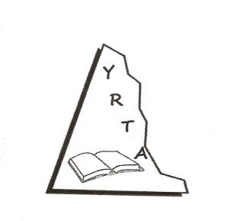

YUKON RETIRED TEACHERS’ ALUMNI

MEMBER INFORMATION

Membership; 145 members (as of November 1, 2017)
Member’s Address: 2064 – 2nd Avenue, Whitehorse, Yukon Y1A 1A9
Member’s Website: n/a

- President:
  - Name: Ken Nash
  - Address: 139 Falcon Drive, Whitehorse, Yukon Y1A 6G7
  - Telephone: 867-633-6880
  - Email: kenandpatti@northwestel.net

- Director ACER-CART:
  - Name: Ken Nash
  - Address: (as above)

- Observer ACER-CART:
  - Name: n/a

- Newsletter Editor:
  - Name: (Vacant)
  - Address:
  - Telephone:
  - Email

- Webmaster:
  - Name: n/a

- Significant Dates:
  - Annual General Meeting
    - Date: September 6, 2018
  - Board of Directors meetings:
    - Dates: 4 times/year
  - Newsletter
    - Name of your Publication: YRTA News & Views
    - Dates of publication: May & November

