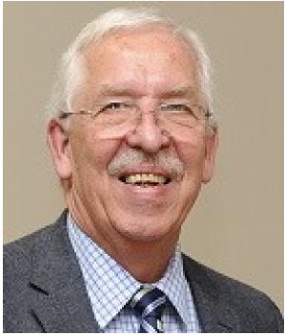
Gordon Cumming
Candidate
REGIONAL REPRESENTIVE - West
ACER-CART

To the Western Voting Members of ACER-CART,

Thank you to the ARTA Board of Directors for my nomination for this Position, and thanks to all of you for considering my candidacy.

I consider myself fortunate to have had a seat at the ‘table’ for the past eight years, representing my colleagues in Alberta. And more so, I have valued the ‘window’ on retired teacher issues and initiatives provided by all the voices from ‘sea to sea to sea’.

I am excited with the prospect of being involved with the ACER-CART Executive, sharing, supporting and contributing to our collective energy and expertise. Having benefitted from the commitment of past Representatives to the task, I believe I am ready to step up.

Together, as an organization, we have to identify and articulate the needs and wishes of our combined membership. We have to recognize the knowledge, and share the expertise that resides in each member organization. We need to communicate effectively with each other, and to those who make decisions that impact our members.

Key areas demanding our advocacy include Pensions, Benefits, Health and Senior Care Initiatives, Pharmacare, and Legislation. Dialogue of common organizational issues and opportunities is of mutual benefit, and ensuring the voice of ACER-CART is anticipated and welcomed best serves us all.
I would consider it a privilege to represent you and work on your behalf.

Gordon

ACER-CART, ARTA and CRTA (Calgary Retired Teachers’s Organization) Involvement:
ACER-CART: Alberta Director 2011 – 2018
Co-organizer the first Western Regional Meeting – November 2017
ARTA: CRTA Director 3 years Executive Member for 7 years Past Member of Benefits,
Communications, Executive, Governance, Membership and Marketing, Pension and
Financial Wellness, SPAC, and Wellness Committees
Alberta Retired Teachers’ Foundation ARTA Liaison 2 years
Director – 2017 -
CRTA: Executive Member for the past 13 years.
Positions include VP, President and Past-President
Currently Chair of “Steppin’ Out” Conference
Husband of an ACER-CART, ARTA and CRTA Member – Bev, who keeps me honest

