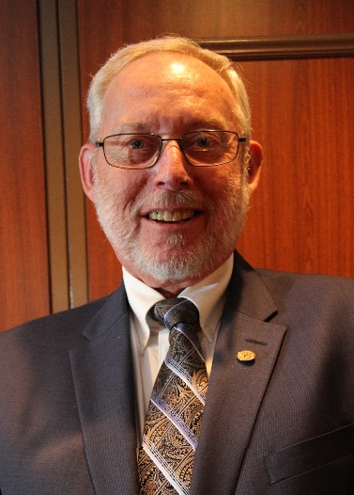

MARTIN HIGGS
Candidate

Regional Representative - Ontario
ACER-CART

Martin is currently the Ontario Representative on the ACER-CART Executive and the immediate Past-President of the Retired Teachers of Ontario. Before being elected to the Provincial Executive, he served on and later chaired the RTO/ERO Communications Committee. As a member of the Provincial Executive he served for three years on the RTO/ERO Health Services Committee and is currently on the Board of Directors of the RTO/ERO Foundation. He has served his local RTO District in a number of capacities, including District President and is currently the District webmaster and newsletter editor.
Martin was a teacher and vice-principal at the elementary level for 34 years. During his teaching career he was heavily involved in the Ontario Public School Teachers’ Federation, being a District President for five years and at the provincial level serving on a number of committees, including chairing the provincial Collective Bargaining Committee for three years and presenting workshops to local negotiators. He was awarded the OPSTF 75th Anniversary Award for his federation work. When the federations were amalgamated into ETFO, Martin served as District Treasurer and provincially as an Ontario Teachers’ Federation representative on the Qualifications Evaluation Council of Ontario.
Since retirement, Martin worked as a consultant to the Ontario Teachers’ Federation for nine years assisting them with their professional development registrations and creating a database for them. In his community, he served on the Board of Directors for two different theatre groups, chaired the Board of Directors of the Peterborough Community Legal Centre for six years and is currently serving on the Board of Directors for the Kawartha Sexual Assault Centre, the first male to be asked to join the Board. Currently Martin is a member of the Age Friendly Communities Committee set up to advise Peterborough City and County Councils.

