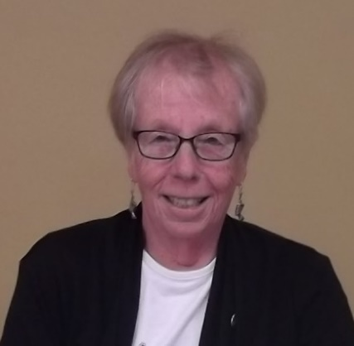

Margaret Urquhart
Candidate
Regional Representative – East
ACER-CART

Since retiring in 2002 being an active member of my local branch of the NBSRT has kept me in touch with former colleagues and enabled me to meet other retirees. Serving on the local Executive Committee as President, Social and Telephone Committee Chair gave provided the opportunity to work on behalf of my retired colleagues.

At the provincial level I have been a Branch Director, 1st Vice-President, President and now Past President. Meeting retirees from around the province underlined the importance of the work of local retired teacher groups. They support and advance the well-being of retirees at the local level. They, truly, are the heart and soul of the provincial association in the same way member associations of ACER-CART are essential to successfully communicating national priorities.

In my early years of retirement, I also supervised student teacher interns for two universities and conducted School Performance Reviews for the Department of Education. I sit on the Board of Commissioners for the Saint John Free Public Library, appointed by the City of Saint John, and was a member of an advisory committee to the city.

As an active teacher I was a classroom teacher, guidance counsellor and school district administrator. Involvements included representing and serving colleagues on local and provincial New Brunswick Teachers Association (NBTA) committees, chairing three of them. As well I was a member of the Executive, including President, of the Atlantic Chapter of the Guidance and Counselling Association and New Brunswick’s representative to the Canadian Guidance and Counselling Association (both now defunct).

Being a member of various Department of Education committees, combined with being chosen to participate in summer programs that took me to the University of Toronto, York University and the London School of Education, enriched my experience and supported my professional growth as an educator.

On a personal level, more time for family – near and far, friends and travel have greatly enriched my life in retirement.

