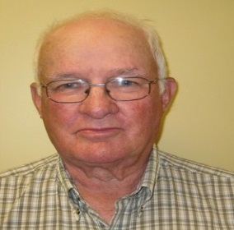
James MacAulay

Candidate
PRESIDENT

ACER-CART

James' early education was gained in his home community of St. Peter' s Bay, PE. After graduating grade ten he went to St. Dunstan's High School in Charlottetown, PE. James graduated from St. Dunstan's University in 1962 with a B.A. Degree. In 1967 he eamed a B Ed. Degree from the same university . In 1978 James graduated from St. Francis Xavier University with a Master' s Degree in School Administration. In 2014 The University of PEI awarded an Honorary Doctorate of Laws Degree.
James teaching career began at Morell Regional High School where he remained for his whole career. During 1987-88 he moved to Morell Consolidated School for a one year exchange program. In 1995 he left Morell High to do a study and write a report on the state of education in The Easter School District in PEI. This report was completed and published in late 1996. The effects of this report are still being discussed in the Eastern School District.
Early in his career, James became involved with The PEI Teachers' Federation. He served on the board of govemors for a number of terms. He chaired Federation committees of Economic Welfare, Finance and Group Insurance. In 1978 he was elected as second vice-president of the Federation and continued through the executive becoming president in 1980. James served on the CTF as director from PEI for a couple of terms. At CTF he chaired the Finance and Staff Committee. Following retirement from active teaching Jim became active in the PEI Retired Teachers' Federation. In December of 2011 he completed two terms as president of this organization. During his term as president, he helped organize and hold the first Atlantic Conference of Retired Teachers.
Besides his work within his teacher organization James has also being quite active in community organizations. He has been very active within The Royal Canadian Legion serving as provincial president from 1997-99. During this time he also served on The Dominion Executive Council of the Legion. In the local community James has held positions in church, community and development organizations. James has received numerous honours for his community work. In 2016 The Eastern Kings Chamber of Commerce award the Pillar of The Community award. In 2016 also The Rotary Club of Montague saw fit to honour James with Paul Harris Fellowship award. In 2016 also The Rotary Club of Montague saw fit to honour James with Paul Harris Fellowship award. In the fall of 2017 James was awarded “The Order of Prince Edward Island”. This is the highest award given in the province. Until the present time James has remained active in his community and has had much success with community improvement.

