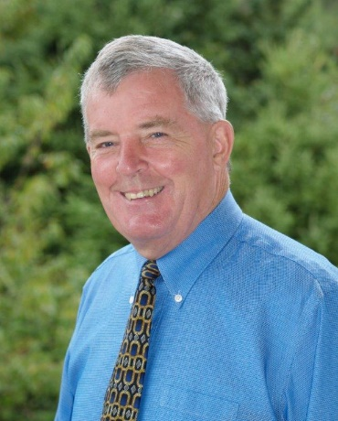
BILL BERRYMAN
Candidate
President
ACER-CART

Teaching Career
Bill began on his teaching career in 1970 as a French and Social Studies teacher. During his teaching career he was heavily involved in activities with the Nova Scotia Teachers Union. He served as President of the Hants West Local for two terms, was a member of the NSTU Provincial Executive for 4 years, served as a First Vice-President of the NSTU for two years and participated in numerous NSTU provincial committees.

Nova Scotia Teachers Union
In 1996 Bill was hired as Executive Staff Officer by the NSTU in the areas of provincial and regional negotiations, grievance procedures, occupational health and safety and public affairs. He co-negotiated the first NSTU contract with the Nova Scotia Community College and negotiated the first French contract with the Conseil Scolaire Acadien Provincial.

Canadian Teachers Federation
After retiring from the NSTU in 2007, Bill was nominated by the Canadian Teachers Federation to serve as a Service Canada Employment Insurance Referee in Nova Scotia. This position involved serving on a quasi-judicial tribunal whereby a person, who was denied employment insurance benefits, had the right to appeal the decision in person with or without legal counsel. Bill served as the employee representative until 2013 when the Harper government disbanded the tribunals across Canada.

Retired Teachers Organization of the Nova Scotia Teachers Union
Bill served as President of the Hants West Branch from 2008–2012. He served on the Retired Teachers Organization Executive as Member-at-Large from the Annapolis Valley from 2010–2012. In 2012, and once again in 2014, he was elected Vice-President of the RTO. In 2016 he was elected President for a two-year term and has been re-elected by acclamation for another two-year term commencing June 1, 2018.

ACER-CART
For the past three years Bill has attended the ACER-CART Annual General Meetings as an observer. He was very fortunate to serve on the ACER-CART Political Advocacy Committee in 2014-2015 which produced the pamphlet “A Vision For Canada.” Bill has enjoyed the activities and discussion at the last three Annual General Meetings and the significant effort which went into producing the pamphlet.

Bill has thoroughly enjoyed the past year as the Regional Representative East on the ACER-CART Executive. As Chair of the Political Advocacy Committee he has researched and written articles on the National Pharmacare Program and Elder Abuse. He believes he has much to offer this great organization and has decided to place his name as candidate to serve as President of ACER-CART.

