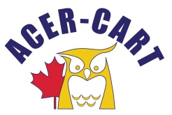
Association canadienne des enseignantes et des enseignants retraités
Canadian Association of Retired Teachers

Date : October 5, 2017
From : Roger Régimbal Executive Director
Objet : Correspondance

Documents sent

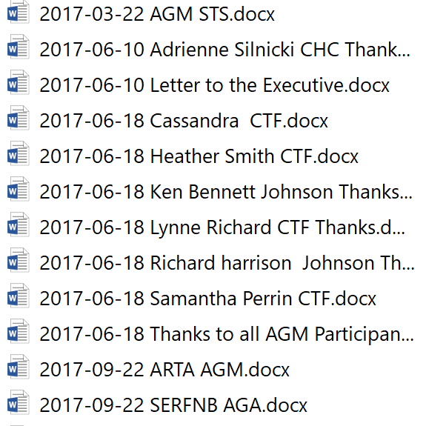

Documents received

None

Thank you
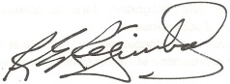
Roger Régimbal
Executive director

