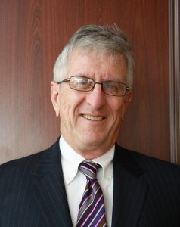
BRIAN KENNY

Candidate

PRESIDENT
ACER-CART

In his 11 years in ACER-CART, Brian has served in a number of capacities, including observer, director, facilitator, regional representative, vice president and president. He continues to be inspired by the leadership and dedication displayed throughout our Member Associations.

Brian began his career in Winnipeg, Manitoba, for 2 years, left to hitchhike across Europe, and then returned to settle in Dryden, Ontario with his wife, Nancy. During those years, he was active in coaching as well as the Ontario Secondary School Teachers Federation and the Ontario Teachers Federation Board of Governors.

Throughout his career, Brian served in a variety of areas and has received awards for coaching, as well as publishing newsletters and writing editorials for his provincial teachers’ magazine. He also did volunteer work, both during his career and in retirement, on 6 occasions in 5 different developing countries.

In retirement, Brian became active with the Retired Teachers of Ontario, serving as chair of the Political Action Committee for 3 years and on the Provincial Executive for 6 years, including president.

During the winter months, Brian and Nancy live in Burlington, close to their 2 children and 4 grandchildren. Brian volunteers 3 days a week at his grand daughters’ school and is vice chair of the Burlington Library Board. For 5 of the warmer months, Nancy and Brian are in northwestern Ontario, at their cabin where Brian is also a member of the Dryden Rotary Club. He is a past president and a past assistant district governor.

Needless to say, Brian and Nancy’s favourite volunteer work involves being with their grandchildren.

